## Project Report On

Online Job Portal System

“A dissertation submitted in partial fulfilment of the requirements of Bachelor of Technology Degree in Computer Science and Engineering of the Maulana Abul Kalam Azad University of Technology for the year 2019 -2023”



Submitted by

Ranajoy Bhowmick-14800120136 Dipayan Dutta-14800120138 Akash Adhikari-14800119005 Deepraj Dutta-14801619039

Under the guidance of

### Prof. Santanu Roy

<Head of the Department>

Department of Computer Science and Engineering (Data Science)

## Future Institute of Engineering and Management

Guide / Supervisor

# Department of Computer Science and Engineering (Data Science)

## Future Institute of Engineering and Management

### Examiner Signature

**Head of the Department**

### Computer Science and Engineering

**Future Institute of Engineering and Management**

## ACKNOWLEDGEMENT

We would like to express our Gratitude to this Major Project guide, Prof. Santanu Roy for his guidance, help, and the many discussion sessions that gave us courage and enthusiasm to design and build this project. We thank all the faculties of CSE Dept, and also for their support and guidance. We extend our gratitude to HOD of CSE department, Prof. Tapas Roy, Also, I would like to thank our every team member for their support and active work. Finally, we would like to thank our college, Future Institute of Engineering and Management for this opportunity to work on this project.

### Mr. Ranajoy Bhowmick

14800120136 and 201480100120003

|  |
| --- |
| Mr. Dipayan Dutta |
| 14800120138 and 201480100120001 |
| Mr. Akash Adhikari |
| 14800119005 and 011652 |
| Mr. Deepraj Dutta |

14801619039 and 033766

## ABSTRACT:-

In the older days searching a perfect job is like find a nail in the sand, so our website come to a complete solution for the job seekers, learners and also the recruiters in. our website a job-seeker can find a perfect job according to their skill-set by applying filters like location, skill, company type, company rating(public), attrition rate, no of employee, revenue & market capitalization, salary range.

Learners got great learning materials by which he/she got the correct knowledge on this topic and also the perfect guidance what to learn next. Experience of Industrial training. Last but not least recruiters will get right candidate who will be perfect of this role at the exact time. They post for vacancy and internship process.

Our website also available highest no of trending jobs Along with a dashboard of current trend skill-set. Job portal services was developed for creating an interactive job vacancy form for candidates. This web application manage the updates both from the job seekers as well as the companies. It’s unique development methodology helps in acquiring the client and candidate information and separating them according to the job requirements and vacancies.

The online access to it provides details of the job. An employer being registered in the website has the facility to use the services. Being an authorized user he can publish vacancy details and can search no of employees on portal and also he can search candidates on basis of the key skill which employee provides on registration.

## CONTENTS CHAPTER 1: INTRODUCTION (01 – 03)

### Objective 02

### Feasibility Study - 03

### 1.2.1 Technical Feasibility----------------------------------------- 03

### 1.2.2 Operational Feasibility---------------------------------------- 03

### 1.2.3 Economic Feasibility 03

## CHAPTER 2: SOFTWARE REQUIREMENT SPECIFICATION (SRS) ------- (04 – 05)

## CHAPTER 3: SOFTWARE DEVELOPMENT PROCESS MODEL (06-09)

3.1 WATERFALL MODEL 07

## CHAPTER 4: OVERVIEW 10

### System Overview 10

### Limitation of Existing System 10

## CHAPTER 5: PROPOSED SYSTEM (11-14)

### Objectives of the proposed system 11

### Users of the Proposed system (12-14)

## CHAPTER 6: TECHNOLOGIES (15-16)

### Development organization 15

### Tools used in development 16

### Software interface 15

### Hardware Used 16

**CHAPTER 7: DESIGN (17-21)**

### Use case Diagram 17

* 1. System Flow Diagram- (18-19)
  2. Data Flow Diagram
     1. Context- Level (Level-0) DFD 20

6.3.2 Context- Level (Level-1) DFD 20

* 1. Entity Relationship Diagram 21

## CHAPTER 8: FUTURE WORK 22

**CHAPTER 9: SNAPSHOTS (**23 **–** 26**)**

## CHAPTER 10: REFERENCES 27

**CHAPTER 11: CONCLUSION** 28

**List of Figures:**

**Fig:1 Water Fall model**

**Fig:2 ………………………… Use case diagram Fig:3 …………………………. System flow diagram**

**Fig: 3.1 Employer**

**Fig: 3.2 Employee**

**Fig:3.3 Admin**

**Fig: 4................................................. Dataflow Diagram**

**Fig: 4.1 Context-Level (Level 0)**

**Fig: 4.2 Context-Level (Level 1)**

**Fig: 5 Entity Relationship Diagram**

## INTRODUCTION:-

A professional networking portal is a type of social networking site where everyone can find their job as well as socially connected to professional life and recruiters can hire employees for their esteemed companies. The purpose is to mainly is to enable applicants in search for a job in convenient manner and to enable employers to find suitable candidates.

Now a day, we know that searching of jobs is so difficult in proficient areas the portal developed for the providing the simple and good job searching. With the help of this portal easily the job seeker can submit their resume and get the lot of opportunity of the job related to their profile. And by this website the companies or employer can also find the good and well profiled resume.

## OBJECTIVE:-

The online job portal system that is to be developed provides the members with jobs information, online applying for jobs and many other facilities. This system provides service to the job applicants to search for working opportunities. The objective of the online job portal is to develop a website for the job applicants, recruiters, learners, where a job seeker can find his dream job and a learners can find good contents. The purpose is to mainly is to enable applicants in search for a job in convenient manner and to enable employers to find suitable candidates.

Job Portal will allow job provider to establish one to one relationships with candidates. This Portal will primarily focus on the posting and management of job vacancies. This system is designed such that ultimately all vacancies will be posted online and would offer employers the

facilities to post their vacancies online. It helps to review and manage the resulting applications efficiently through the web. Employer can also find the resume according to key skill in very less amount of time

## FEASIBILITY STUDY:-

Basically a Feasibility a details analysis that consider of all the detail aspects of in order to determine the likelihood of it succeeding. It is simply an assessment of the practically of proposed project plan or method. There are 3 types of feasibility study like-

## TECHNICAL FEASIBILITY:-

Technical feasibility study as a concerned with specifying equipment and software the successfully satisfy the user requirement. The technical needs of the system may very considerably, and the facility to produce outputs in a given time. It considers the technical requirements of the proposed project. The technical requirements are then compared to the technical capability of the organization. The systems project is considered technically feasible if the internal technical capability is sufficient to support the project requirements.

## OPERATIONAL FEASIBILITY:-

Operational feasibility study is used to check the project is feasible or not. Our project is mainly student hiring process which is based on current trend skill set. Operational feasibility is a measure of how well a proposed system solves the problem and takes advantage of the opportunities identified of during scope definition and how is satisfies the requirements the identified analysis phase of system development. Operational feasibility reviews the willingness of organization to support the proposed system.

## ECONOMIC FEASIBILITY:-

Economic feasibility is the measure to determine the cost and benefit of the proposed system. A project is economical feasible which is under the estimated cost for its development. These benefits and costs may be tangible or intangible. Job Portal is the cost-effective project in which there is less possibility of intangible cost so there is no difficulty to determine the cost of the project.This kind of analysis takes into consideration the cost of both developing and operating the new venture. The practice is a way of reducing the risk of trying new ventures. A wide array of factors is considered, and if they show that the idea is cost effective, then it typically will be adopted.

## SOFTWARE REQUIREMENT SPECIFICATION:-

The production of the requirements stage of the software development process is **Software Requirements Specifications (SRS)** (also called a **requirements document**). This report lays a foundation for software engineering activities and is constructing when entire requirements are elicited and analysis. **SRS** is a formal report, which acts as a representation of software that enables the customers to review whether it (SRS) is according to their requirements. Also, it comprises user requirements for a system as well as detailed specifications of the system requirements.

## CHARACTERISTICS OF SRS:-

Correctness: This will be the genuine requirements which will be the part of SRS Complete: software system will perform each and every functions as per the SRS

Unambiguous: which means not confusing, every requirement will be specified in the SRS which will have only one meaning.

Verifiable: this will do the cross verifying oft he SRS which is understood by software. Consistent: which means stable due to the non conflicting requirement.

Modifiable: if necessary changes can be made which doesn’t affect the consistency and also the completeness

Traceable: origin of the requirement should be clear that the future assist verification and also validates.

## SOFTWARE DEVELOPMENT PROCESS MODEL ADOPTED:-

A software process model is an abstraction of the software development process. The models specify the stages and order of a process. So think of this as a representation of the order of activities of the process and sequence in which they are performed.

## A Model will define the following:

The tasks to be performed**.**

The input and output of each task

The pre and post conditions for each task The flow and sequence of each task

## WATERFALL MODEL:

Waterfall model is the first SDLC model to be used in widely in software Engineering to ensure success of the project. In “THE WATERFALL “ approach the whole process of software development is divided into separate phases. In the waterfall model , typically the outcome of one phase as acts as the input of next phase sequentially.

## DIAGRAM:



Define Requirement

System software and design

Implementation &

Unit Test

Integration & System Testing

pg. 13

Operation &

Maintenance

**Why We Choose That Model**:

Fig : 1 : Diagram of Waterfall Model

. Because the Waterfall model is effective for projects that involve several steps to production. It is the

better formation model that plan on moving fast, and this is the most efficient system to incorporate. This model is suited to projects with deliveries that are easy to the start.

## WATERFALL MODEL DESCRIPTION:

1. **Define requirement**:

##### Requirements analysis and specification:

The aim of the requirement analysis and specification phase is to understand the exact requirements of the customer and document them properly. This phase consists of two different activities.

##### Requirement gathering and analysis:

First of all the requirements regarding the software are gathered from the customer and then the gathered requirements are analyzed. The goal of the analysis part is to remove incompleteness

(an incomplete requirement is one in which some parts of the actual requirements have been omitted) and inconsistencies (an inconsistent requirement is one in which some part of the requirement contradicts some other part).

##### Requirement specification:

These analyzed requirements are documented in a software requirement specification (SRS) document.

SRS document serves as a contract between the development team and customers. Any future dispute between the customers and the developers can be settled by examining the SRS document.

## System software and design:

The goal of this phase is to convert the requirements acquired in the SRS into a format that can be coded

I in a programming language. It includes high-level and detailed design as well as the overall software architecture.

A Software Design Document is used to document all of this effort (SDD)

## Implementation and Unit Tests

In the coding phase software design is translated into source code using any suitable programming language.

Thus each designed module is coded. The aim of the unit testing phase is to check whether each module is working properly or not.

## Integration and System testing:

Integration of different modules are undertaken soon after they have been coded and unit tested. Integration of various modules is carried out incrementally over a number of steps.

During each integration step, previously planned modules are added to the partially integrated system and the resultant system is tested. Finally, after all the modules have been successfully integrated and tested, the full working system is obtained and system testing is carried out on this.

System testing consists of three different kinds of testing activities as described below:

* 1. Alpha testing: Alpha testing is the system testing performed by the development team.
  2. Beta testing: Beta testing is the system testing performed by a friendly set of customers.
  3. Acceptance testing: After the software has been delivered, the customer performed acceptance testing to determine whether to accept the delivered software or reject it.

## Maintenance:

Maintenance is the most important phase of a software life cycle. The effort spent on maintenance is 60% of the total effort spent to develop a full software. There are basically three types of maintenance .

* 1. Corrective Maintenance: This type of maintenance is carried out to correct errors that were not discovered during the product development phase.
  2. Perfective Maintenance: This type of maintenance is carried out to enhance the functionalities of the system based on the customer’s request.
  3. Adaptive Maintenance: Adaptive maintenance is usually required for porting the software to work in a new environment such as working on a new computer platform or with a new operating system.

## OVERVIEW:-

**SYSTEM OVERVIEW:-**

The online job portal application allows job seekers and recruiters to connect. The application provides the ability for job seekers to create their accounts, upload their profile and resume, search for job, view different job openings. The applications provides the ability for employers to create their accounts, search candidates, create job postings, and tracked contacted candidates. The job portal will both the job seekers and recruiters finding the right organization for the employees**.**

## Limitation of Existing System

Not available as a mobile application. Chatbot is under development**.**

## SOLUTION OF THESE PROBLEM:-

The development of the new system contains the following activities, which try to automate the entire process keeping in view of the database integration approach.

* We currently developing on the mobile application.
* We currently developing on the chatbot

## PROPOSED SYSTEM:-

The proposed system is a web based application which allows applicants and employers to register their details. Applicants can browse through the vacancy details that are posted and can apply for the jobs online. Employers can browse through the posted resumes and select suitable candidates.

## OBJECTIVE OF THE PROPOSED SYSTEM:-

This project has been mainly designed to overcome some of the problems faced with the previous system. The main problem faced was unnecessary delay in generating the required information by all unnecessary fields into consideration. It provides an efficient way to pass the information between different users to cater their needs. It is a Complete Portal for Job seekers and employers. It is an exclusive career portal aimed just for the service of job seekers. It is a common platform where corporate recruiters and job seekers come under roof.

## USERS OF THE PROPOSED SYSTEM:-

|  |  |  |
| --- | --- | --- |
|  | **PERMISSIONS** | **ROLES AND RESPONSIBILITIES** |
| ADMIN |  | 1.Manage Job Seeker and Employer Profiles. |
|  | 2.Manage Payments of Both Employer and Job Seekers. |
|  | 3.Add New Services, Related to Employers or Job Seekers. |
| * Create a new user. | 4.Send Message to Employer and Job seeker for Subscription etc. |
| * View any the user. | 5.Provide Roles and Authentication to Users. |
| * Edit any the user. | 6.Ability to change the look and feel of your site by changing template. |
| * Delete any the user. | 7.Most Recent Jobs to be displayed on home page. |
|  | 8.Search jobs based on keywords, categories, locations etc. |
|  | 9.Create / Edit / Save as many icon sets as you like |
|  | 10.Location management console to add/edit/remove locations for which jobs can be posted. |
|  | 11.Manage premium employers. 12Apply for a job with the click of a 13. Resume Posting.   1. Automatically retrieve passwords by email 2. Job Seeker Registration |

|  |  |  |
| --- | --- | --- |
| EMPLOYER | * Create his own profile. * View all the employee’s   profile.   * Edit his own profile. * Delete his own profile. | 1.Login and update profile, including forgotten password reminders  2.View Application History from profile  3.Powerful online job search tool.  4.Job seeker sets ’privacy level’ to control how much information is visible to employers through resume searches.   1. Search jobs by location, qualification, categories, company, location, experience and keywords. 2. Hide contact information. 3. Add multiple list of qualification and experience. 4. Ability to add and submit Photos to profile. 5. Ability to add Cover Letter when apply for job. 6. Add, Edit, Activate or Delete Job Search Agent. 7. Ability to Search resume by keywords   Job category, days since posted.   1. Post jobs with detailed job description   (job title, company name, company url, location, salary, job type, work type, description, required skills...) |

|  |  |  |
| --- | --- | --- |
| EMPLOYEE | * Create his own profile. * View only his own profile. * Edit only his own profile. * Delete his profile after ADMIN permission. | 1.Retrieve passwords reset by automated email.  2. Reporting information on how much time left on each job posting and how long left on CV access  3.Payment option by invoice, credit/debit card.   1. Information on number of vacancy viewings and applications 2. Register and sign-up online for Memberships, Job packages, job postings or resume database access. 3. Option of including company profile and logo. 4. New Account Notification - an email message is sent to them as autoresponder with username and password. 5. Retrieve passwords by automated email. 6. Update profile at any time. 7. View Submitted Job Seeker CV 8. Download CV or application submitted by jobseekers |

.

**TECHNOLOGIES**

* + - **SOFTWARE:**

1. DEVELOPMENT ENVIRONMENT :
   1. Visual Studio Code **(version 1.73)**
2. [BROWSER :](https://try.bravesoftware.com/mdf201/)
   1. **Google Chrome (version 107.0.5304.107)**

### Platform :

* 1. **Windows ( version 10)**

1. FRONTEND:
   1. HTML (version-5 ): is used to describing the structure of our website
   2. CSS (version-3): is used to style our html document.
   3. JAVASCRIPT (version **ES13)**: is make our website interactive .
   4. BOOTSTRAP (version 5): is a CSS framework to make our website mobile responsive.
2. BACKEND:
   1. NODE.JS ( version -16.13.1) : runtime environment which is execute java-script code on the server- side.

ii) EXPRESS.JS ( version- 4.18.2): is a NODE.JS framework which provides a robust set of features for mobile and web application.

1. DATABASE:
   1. MYSQL(version – 8.0): is relational database management system which store all data of our project.
2. SERVER:
   1. XAMPP (version **- 7.4.30**): is a web server which provide response of the client request.
3. Tool:
   1. PHPMYADMIN( version- 5.2.0) : is a administration tool for my-Sql.
      * HARDWARE:
      1. RAM: 1 GB (further increase that a per requirement.)
      2. Hard-Disk: 80 GB (further increase that as per requirement)Display: 1024*768, True Type Colour- 32 Bit
      3. Mouse: Any Normal Mouse
      4. Keyboard: Any Window Supported Keyboard

**DESIGN:-**

##### USE CASE DIAGRAM:



REGISTRATION

LOGIN

SEARCH

FEEDBACK

PROFILE

POST JOB

Employer

Employee

Admin

Fig : 2 : Diagram of Use Case

## Employer:

**Employee:**

## System Flow Diagram

Fig : 3.1 : Employer



Registration/Login

Manage Account

Upload Resume

Search Job

Logout

Apply Job

Registration/Login

Manage Account

Upload jobs

Search Key word for Resume

logout

Message send to employee

Fig : 3.2 : Employee

## ADMIN:

Login

View

Update Create/Delete

Resume Requirements

Permission

Employer Employee

Logout

Fig : 3.3 : Admin

Fig : 3 : System Flow Diagram

**Data flow Diagram**

### Context-Level (Level - 0) DFD:-

REQUEST

**JOB SEEKER**

**JOB**

**ADMIN**

**EMPLOYER**

RESPONSE

Fig: 4.1: Context –Level (Level – 0) DFD

### Context-Level (Level - 1) DFD:-



JOB MANAGEMENT

GENERATE JOB REPORT

APPLICANT MANAGEMENT

GENERATE APPLICANT REPORT

COMPANY MANAGEMENT

GENERATE COMPANYREPORT

JOB APPLICATION MANAGEMENT

ONLINE JOB PORTAL

GENERATE APPLICATIONREPORT

LOGIN MANAGEMENT

CHEK LOGIN DETAILS

SYSTEM USER MANAGEMENT

GENERATE USER SYSTEM REPORT

Fig : 4.2 : Context – Level (Level 1) DFD

#### ENTITY RELATIONSHIP DIAGRAM:- NAME

ROLE

TITLE CITY

1:1 1:1

PROFILE

1:1

1:1

1:1

n:1

MAIL

EDUCATION

WORKING n:1

1:1

n **APPLY** 1 EMPLOYEE

n:1

1:1

RESUME

HOURS JOB

n:1

SALARY 1:1 n

n 1:n

m

1:n

1:n SKILL

ADDRESS

**JOB ID**

n

CONTACT

**POST**

1 n

1:1

**MANAGE**

1

**EMPLOYER**

**_ID** EMPLOYER

n 1

**MANAGE**

MAIL

n:1

1:1 1:1

1:1

1:n

JOB DETAILS

1 ADMIN

1:1

COMPANY NAME

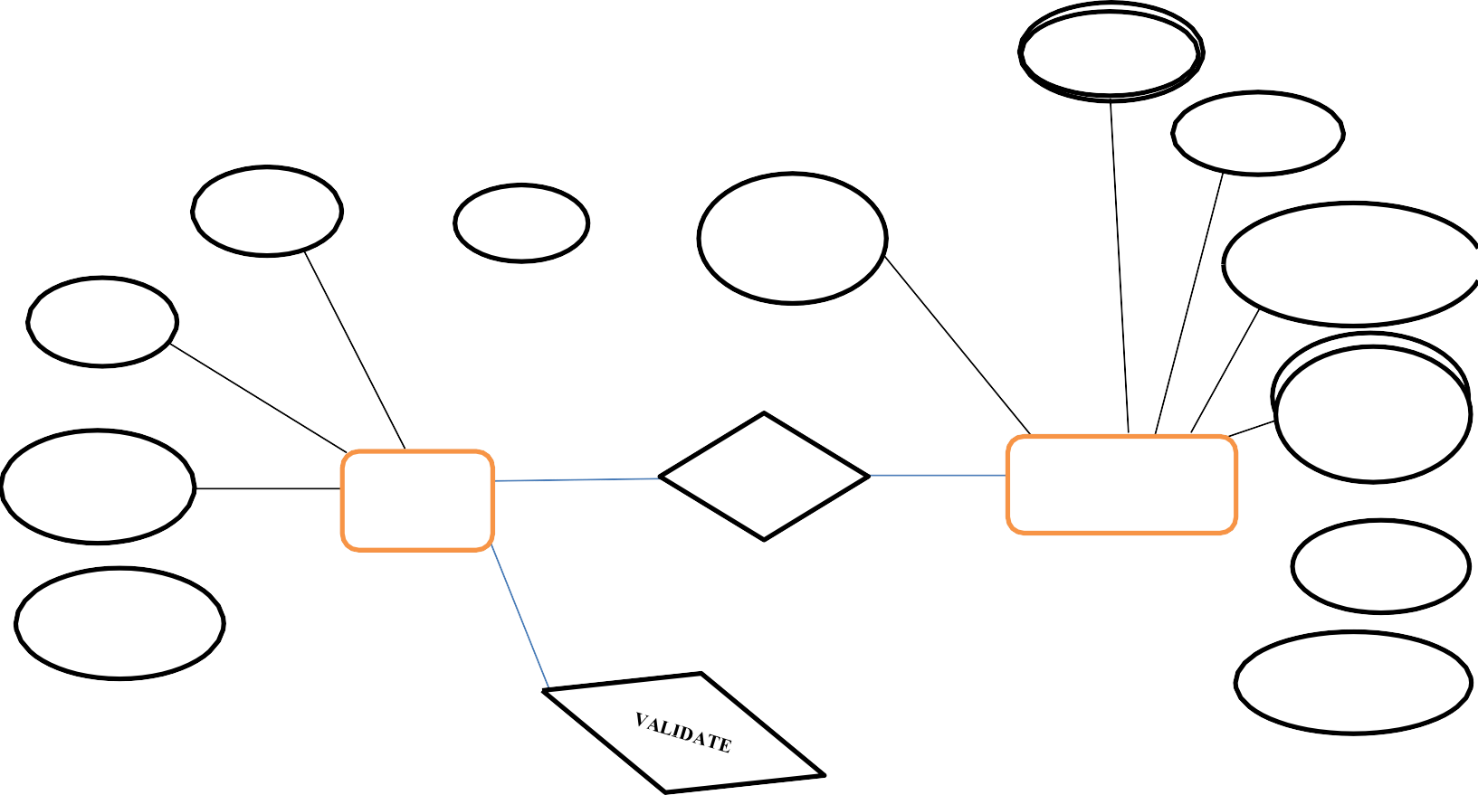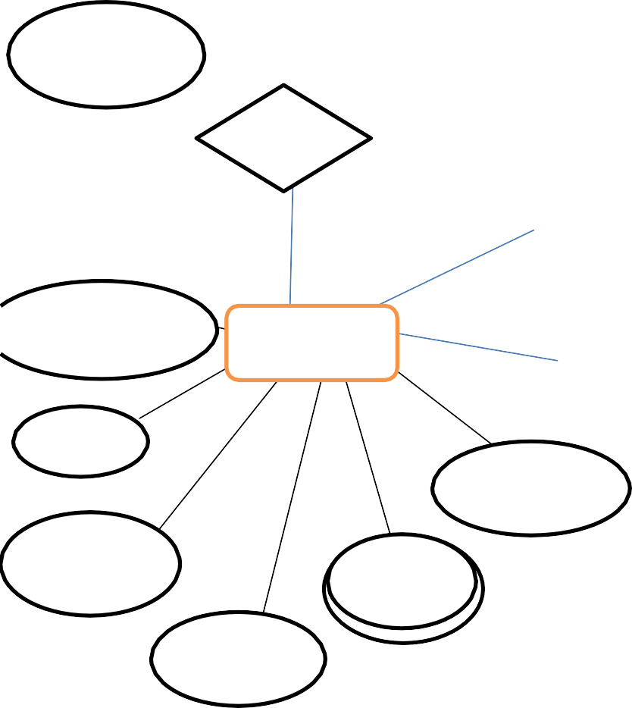

ADDRESS

NAME

Fig :5 : Entity Relationship Diagram Page- 21

1:1

**USER NAME**

PASS WORD

**FUTURE WORK:-**

As of Indian market, there is sample opportunities for the job portal sites, as more and more number of educated and skilled young people are coming out each and every year. Also, as the growth rate of India is zooming to be at a healthy rate over 7%, so it is boom time for corporate also. So, more and more number of lucrative careers will be available for the job seekers. So, it is now the right period for the job portal sites to think out of the box, and make most the opportunities available.

#### SNAPSHOTS:

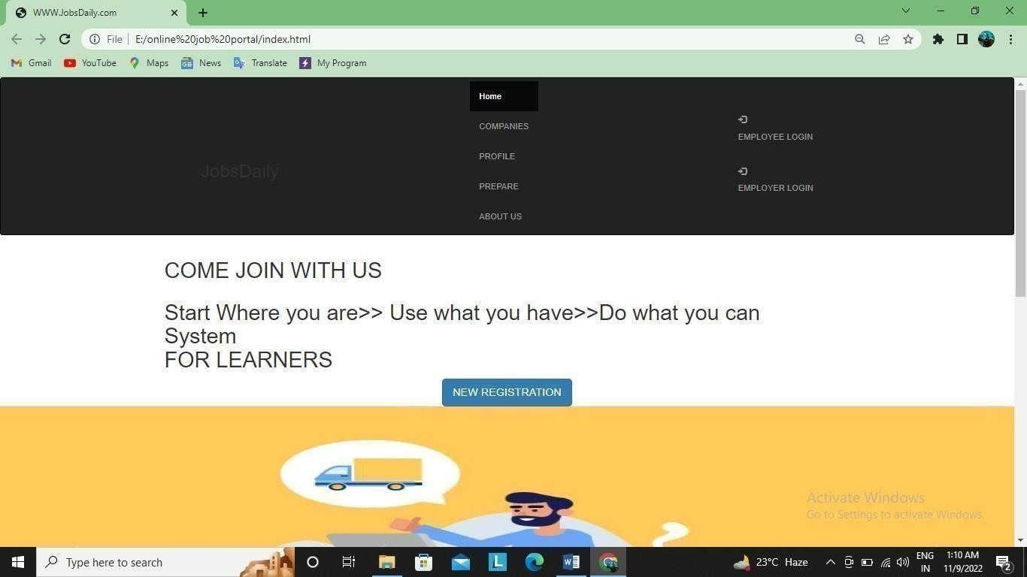

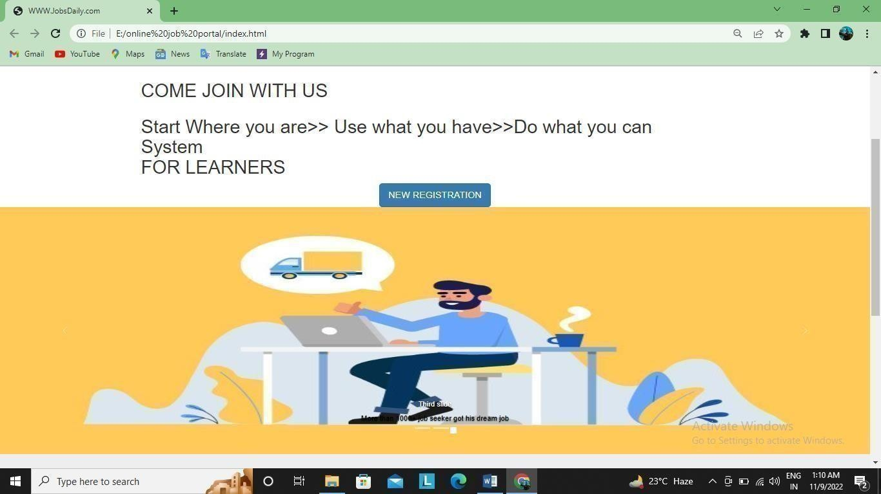

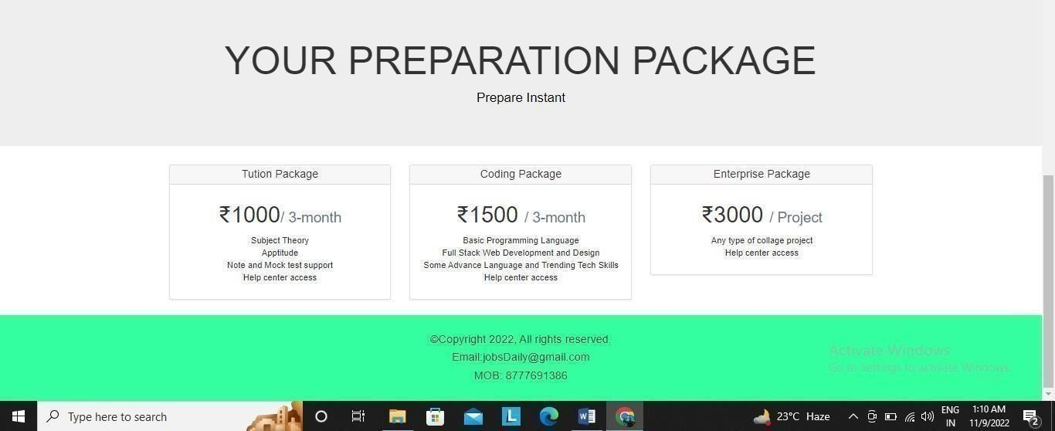

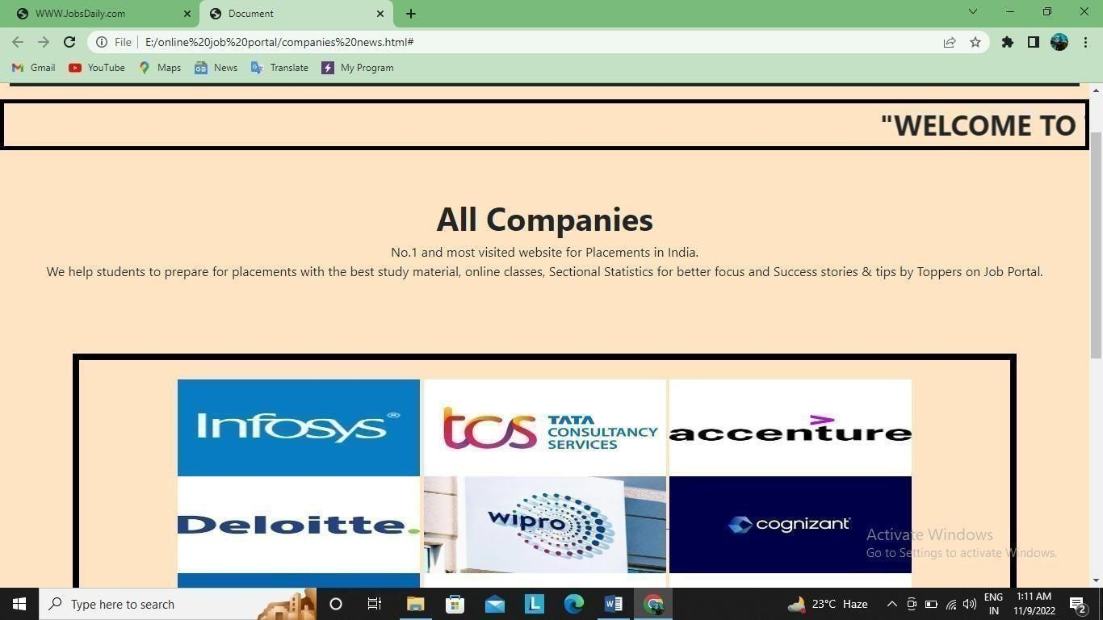

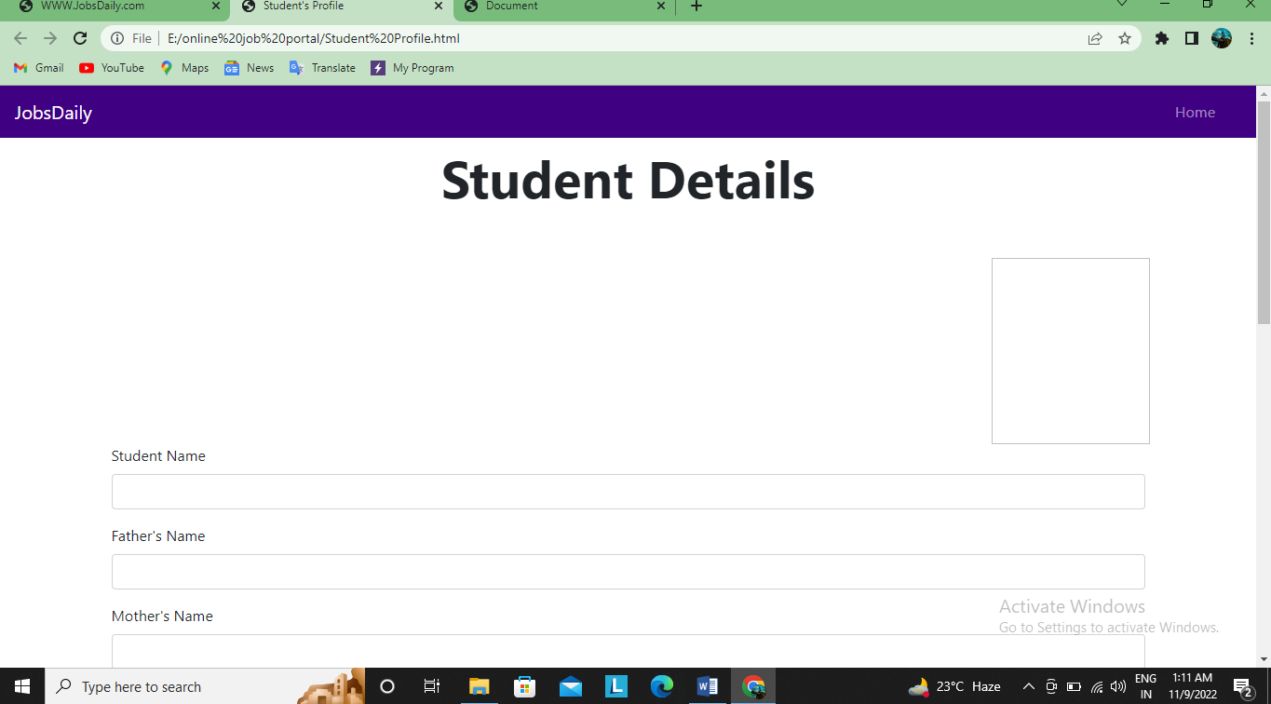

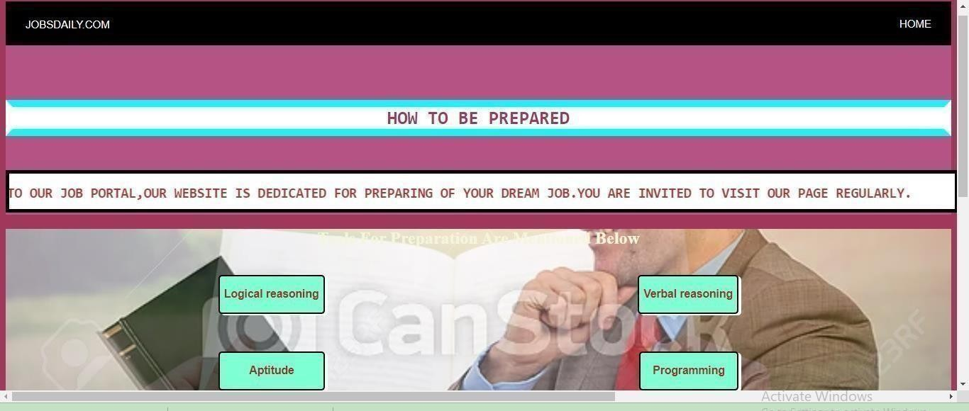

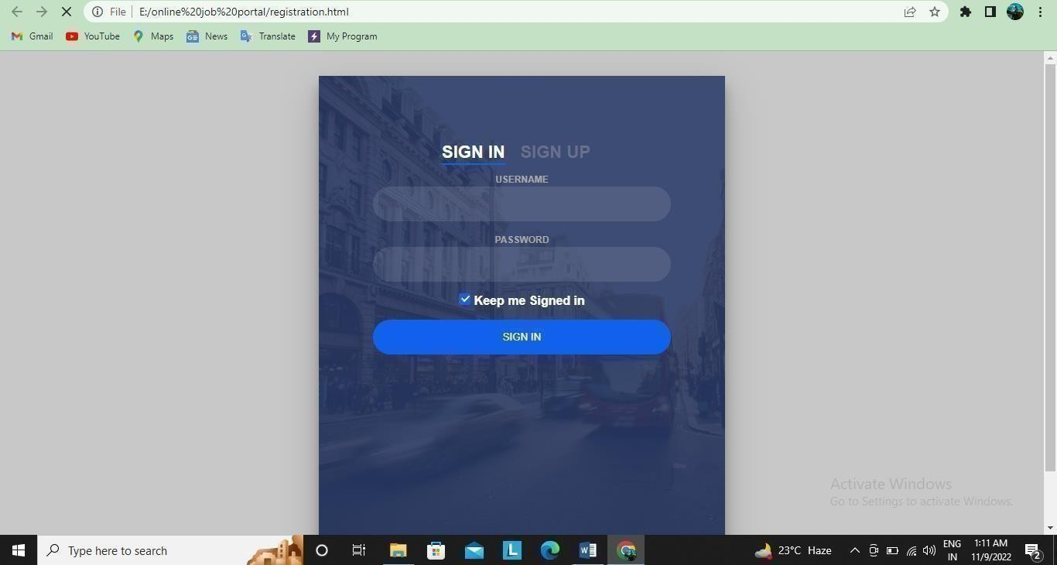

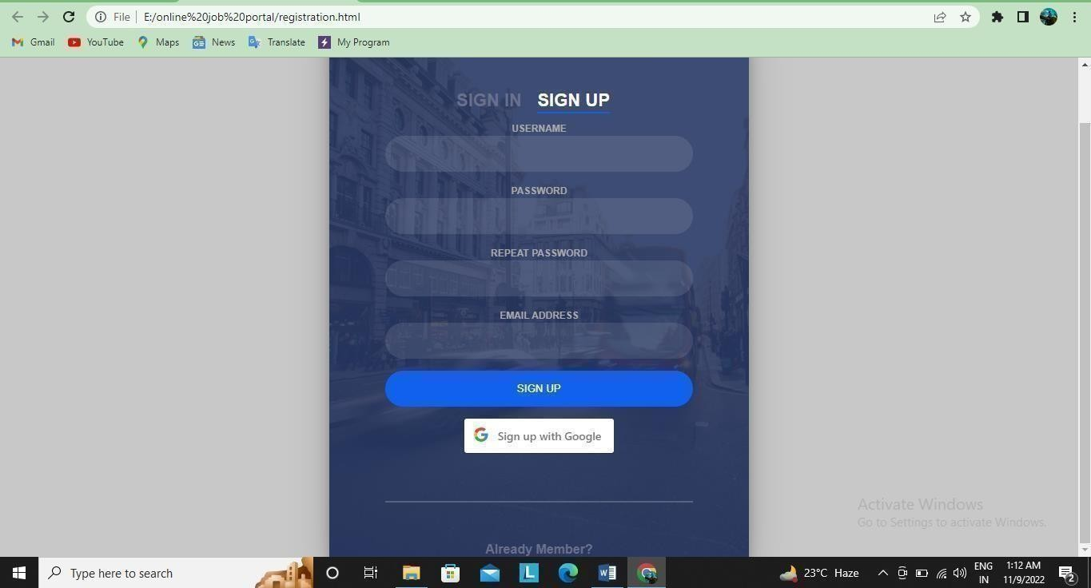

Page- 26

## REFERENCES:

[Register on Naukri.com: Apply to Millions of Jobs Online](https://www.naukri.com/registration/createAccount)

[W3Schools Online Web Tutorials](https://www.w3schools.com/)

[Stack Overflow - Where Developers Learn, Share, & Build Careers](https://stackoverflow.com/)

[Bootstrap · The most popular HTML, CSS, and JS library in the world. (getbootstrap.com)](https://getbootstrap.com/)

[Glassdoor Job Search | You deserve a job that loves you back](https://www.glassdoor.co.in/index.htm)

## CONCLUSION:

### It has been a great pleasure for me and my team to work on this exciting and challenging project. This project proved good for me as it provided practical knowledge of not only programming in web-based application and no some extent Windows Application and SQL Server, but also about all handling procedure related with online job portal. It also provides knowledge about the latest technology used in developing web enabled application and client server technology that will be great demand in future. This will provide better opportunities and guidance in future in developing projects independently.